# Task 2 Questions:

# Opinion (Agree or Disagree):

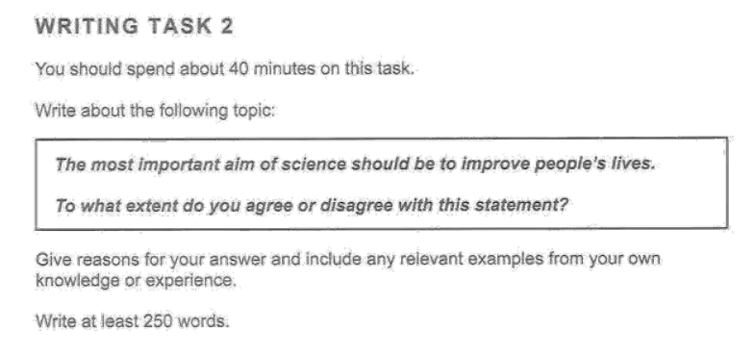



Agree

Ideas:

* Medical – Medical revolution over the years has increased humans span of living and has terminated a lot of diseases e.g penicillin for fighting against bacterial infections.
* Technology – Providing ease to people so they can do more work in less time e.g AI etc.

Synonyms:

Lives – Life style,

People – Humans, Living Beings, Homo sapiens

Improve – enhance, positive progress

Aim – Purpose, Ambition, Goal,

Important – Significant, Valued, has more meaning

Without Guidance from 3rd Party Tools

It is argued that one of the significant purposes of science is to enhance human lifestyle. This essay agrees with that statement. I believe that science has a major contribution in improving people’s lives with medicine and technology being at the forefront.

The medical revolution from science has enhanced lifestyle by tremendous folds. People struggling like me from asthma can now breathe easily and enjoy nature as most people. As science evolved with it the medical branch of science also grew over the years. Each discovery led to a pathway to improve a common person’s life. It is estimated that medical revolution in the past 70 years has saved at least 50 million People from deadly viruses, diseases etc. The governments should spend more on medical research so we can find cures for diseases like cancer. Most recent examples of the Covid-19 emphasize why science is so important for improving people’s lives.

The technological revolution has provided significant improvement for human beings over the course of decades. Now we are connected within seconds with our loved ones. People like me are doing jobs from across the globe just sitting at home and earning more than we could from our home countries. Artificial Intelligence is the new face of our era, where automation is being done to reduce redundant tasks and allowing humans to make breakthroughs which were deemed as impossible before in fields like manufacturing, surgery etc. Most recent examples are of people building startups using AI technologies such as AI Models to perform certain specialized tasks for their customers such as drafting legal documents based on user’s previous documents decreasing lawyers draft time by 58%.

In conclusion, science for good from Penicillin to Self-Driving cars has allowed people to focus on improving their lives and pay attention to issues that need to be addressed.

Refined with 3rd Party Tools:

It is argued that one of the significant purposes of science is to enhance human lifestyle. This essay agrees with that statement. I believe that science has a major contribution in improving people’s lives with medicine and technology being at the forefront.

The medical revolution from science has enhanced lifestyle tremendously. People struggling like me with asthma can now breathe easily and enjoy nature as most people. As science evolved with it the medical branch of science also grew over the years. Each discovery led to a pathway to improve a common person’s life. It is estimated that the medical revolution in the past 70 years has saved at least 50 million people from deadly viruses, diseases, etc. The governments should spend more on medical research so we can find cures for diseases like cancer. Most recent examples of COVID-19 emphasize why science is so important for improving people’s lives.

The technological revolution has provided significant improvement for human beings over the course of decades. Now we are connected within seconds with our loved ones. People like me are doing jobs from across the globe just sitting at home and earning more than we could in our home countries. Artificial Intelligence is the new face of our era, where automation is being done to reduce redundant tasks and allow humans to make breakthroughs that were deemed impossible before in fields like manufacturing, surgery, etc. Most recent examples are of people building startups using AI technologies such as AI Models to perform certain specialized tasks for their customers such as drafting legal documents based on users’ previous documents decreasing lawyers' draft time by 58%.

In conclusion, science for good from Penicillin to Self-Driving cars has allowed people to focus on improving their lives and pay attention to issues that need to be addressed. That is the reason why governments should spend more on scientific research aimed at improving the general population's living standards.

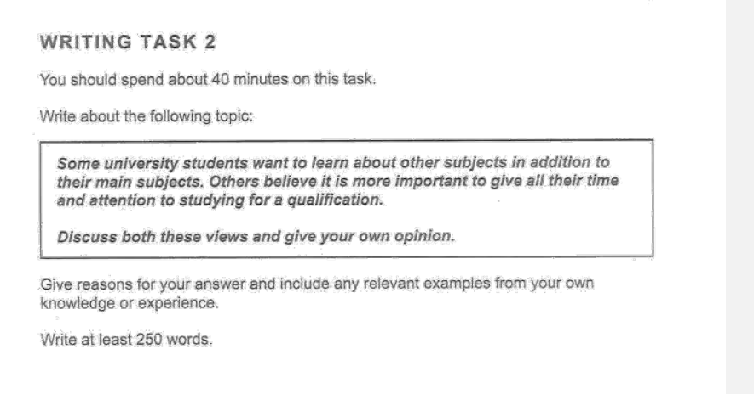

# Discussion Essays

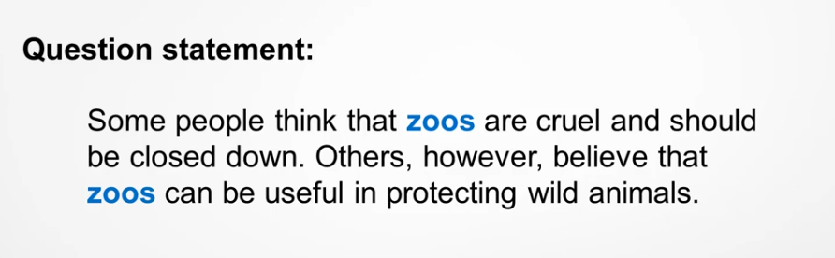



Need to discuss both views

Ideas:

* Zoos constrain animals from living in their natural habitats and adapt to the artificial ones.
* Zoos protect endangered species to live in an artificial environment that is secure and mimics their natural habitat

Synonyms:

People: Humans, Population, Human Beings, Individuals, Humankind

Cruel: ill Treatment, brutal, inhuman, barbaric, vicious, fierce, wicked, evil

Protecting: Securing, Shielding, Defending, Keep Safe

Wild Animals: creatures, species

Useful: Advantageous, Fruitful

It is argued that Zoos are making wild animals suffer alongside Zoos as a source of protector for the endangered species to remain secure. This essay will discuss both viewpoints. The following paragraphs would discuss how Zoos constrain the creatures in their artificial zones and how Zoos have provided shelter for the endangered creatures to strive in.

On one hand Zoos protect the endangered species to foster and grow in an artificial environment that mimics their natural habitat. This is important for securing these creatures from predators or uncontrollable circumstances such as environmental temperatures etc. The species after having enough population and good amount of care can then be slowly transitioned towards their natural habitats. This has been done for Pandas in China where the female Pandas would kill their children thus slowly their population was declining over time but because of Zoos this became a controlled event allowing their population to foster over time.

On the other hand, Zoos constrain animals from living in their natural habitats and spend their lives in a caged environment where there are many cases for ill treatment by the Zoo authorities. Ill treatment not only violates international law but can lead to death of these species by the hand of us humans. An example of this commonly seen Karachi & Lahore Zoos in Pakistan where mismanagement & lack of quality feed led to the death of an Elephant.

In conclusion, Zoos have their roles in protecting endangered species and cases of ill treatment in a caged environment because of lack of care. The latter should not exist, a proper check and balance from the government authorities is needed to keep an eye on the animal’s growth.

3rd Party Tools Enhancement:

It is argued that zoos are making wild animals suffer alongside zoos as a source of protection for endangered species to remain secure. This essay will discuss both viewpoints. The following paragraphs will discuss how Zoos constrain the creatures in their artificial zones and how Zoos have provided shelter for the endangered creatures to strive.

On one hand, Zoos protect endangered species by fostering and growing in an artificial environment that mimics their natural habitat. This is important for securing these creatures from predators or uncontrollable circumstances such as environmental temperatures etc. The species after having enough population and a good amount of care can then be slowly transitioned towards their natural habitats. This has been done for Pandas in China where the female Pandas would kill their children thus slowly their population declined over time but because of Zoos, this became a controlled event allowing their population to be fostered over time.

On the other hand, Zoos constrain animals from living in their natural habitats and spend their lives in a caged environment where there are many cases of ill-treatment by the Zoo authorities. Ill treatment not only violates international law but can lead to the death of these species at the hands of us humans. An example of this is commonly seen in Karachi & Lahore Zoos in Pakistan where mismanagement & lack of quality feed led to the death of an Elephant.

In conclusion, Zoos have their roles in protecting endangered species and cases of ill-treatment in a caged environment because of lack of care. The latter should not exist, a proper check and balance from the government authorities is needed to keep an eye on the animal’s growth.

# Advantages & Disadvantage

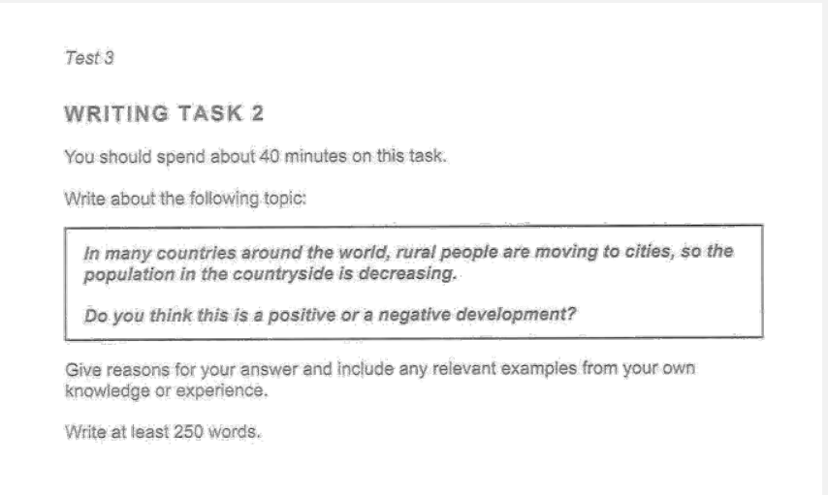

Something here

# Problem & Solution:

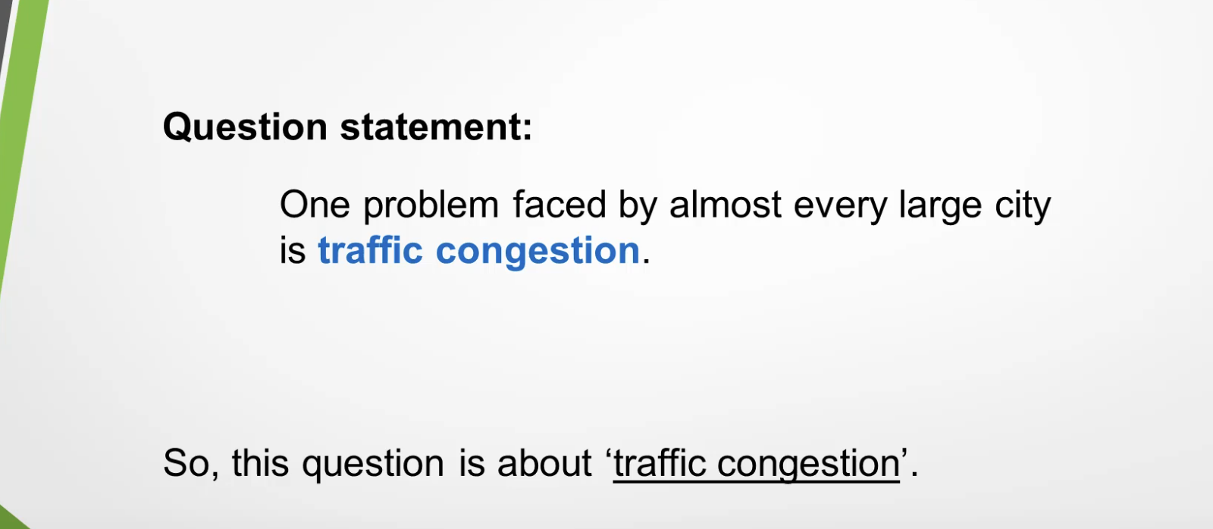



Problem – Obstacle, Issue, Blocker, resulting, situation

Cause – Reasons, why

Solution – Deal with, addressed, tackled, remedied, improved, measures taken, solved, prevent

Large City – Densely populated area, Metropolitan Area

Traffic Congestion – Traffic blockade

Problem:

Too many cars on a road. Why? Too many people own cars and vehicles.

….

# Task 2 Questions:

## Line Graph:

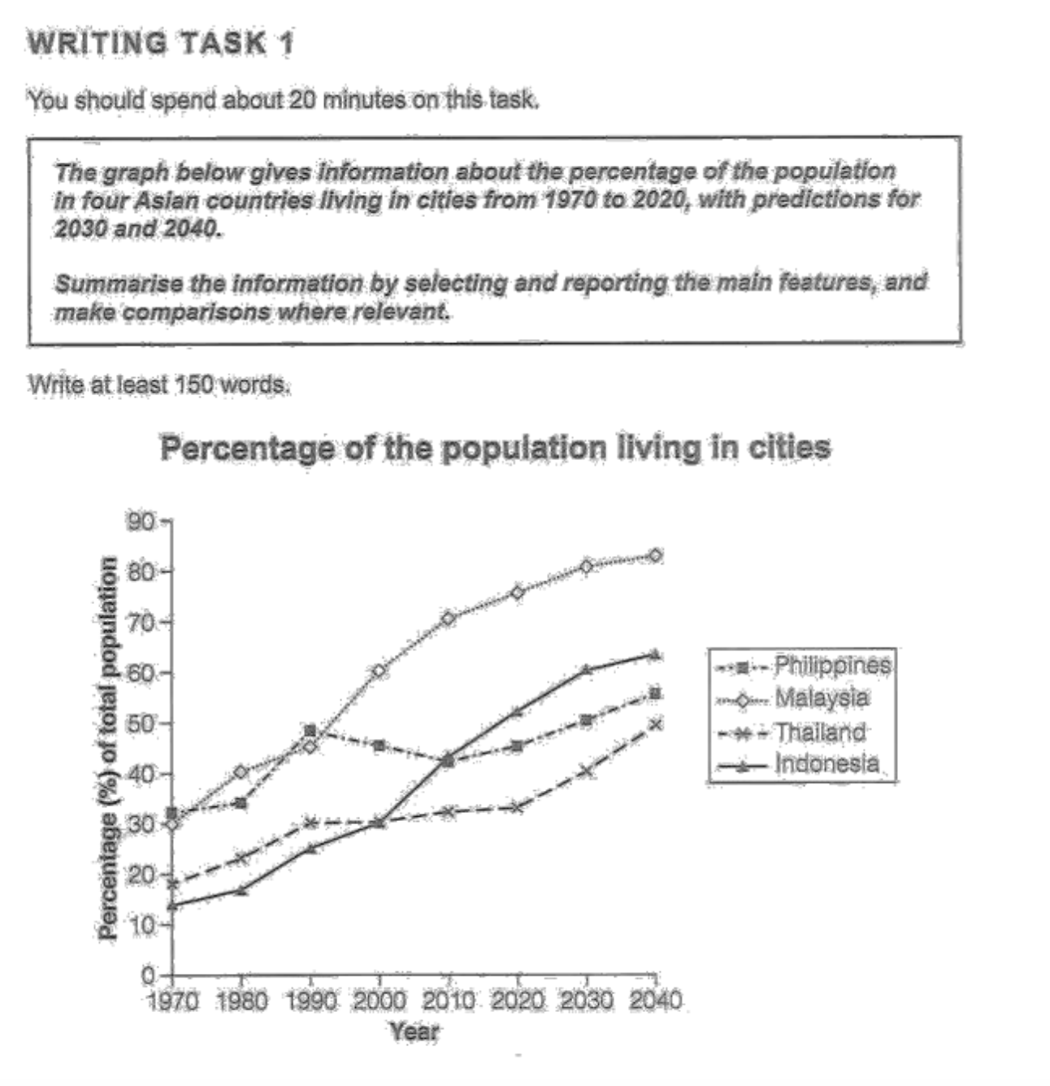



Population of Malaysia, Indonesia and Thailand growing exponentially.

Philippines population getting hiccups but growing stagnantly.

Synonyms:

Population: Density of Human Beings,

Summarize: Brief, shorten

Information: knowledge,

Ideas:

1. Most of the countries city population is increasing may be of the following factors such as life style, opportunities etc.
2. Philippines city population took a dip in 2000 all the way to 2010 which indicates people moving abroad or moving to rural areas.
3. The most astounding rise to population is of malayisa which I think majorly is because of Chinese and Indians moving into Malaysia and developing its cities and infrastructure such as Kuala Lumpur similar to whats happening in Indonesia.

The line graph shows cities population growth between from 1970 to 2020 with a projected growth from 2030 to 2040 among countries such as Philippines, Malaysia, Thailand and Indonesia.

Overall, most countries city population is increasing over the period especially Malaysia and Indonesia whilst Philippines city population to a dip in 2000 all the way to 2010 which indicates people may have been moving abroad or moving to rural areas.

Throughout all years we can see the population increasing over the years in most countries especially with Malaysia and Indonesia where multiple variables are causing this such as Chinese and Indians moving to Malaysia. These countries are investing, developing infrastructure and providing labor which ultimately is leading to more people coming into the countries to find better opportunities and lifestyle. Thus the reason why the projection of 2030 and above points towards more population.

We can also see a different pattern emerging for Philippines especially from the period of 1990 to 2010 where the. Urban population dipped which may indicate people move abroad or moving to rural areas. But the population again is rebounding in the cities as the projection above illustrates a similar figure.

3rd party tool enhanced version

The line graph shows cities' population growth between 1970 and 2020 with projected growth from 2030 to 2040 among countries such as the Philippines, Malaysia, Thailand, and Indonesia.

Overall, most countries' city populations increased over the period especially Malaysia and Indonesia whilst the Philippines' city population to a dip from 2000 all the way to 2010 which indicates people may have been moving abroad or moving to rural areas.

Throughout all years we can see the population increasing over the years in most countries, especially with Malaysia and Indonesia where multiple variables are causing this such as Chinese and Indians moving to Malaysia. These countries are investing, developing infrastructure, and providing labor which ultimately is leading to more people coming into the countries to find better opportunities and lifestyles. Thus the reason why the projection of 2030 and above points towards more population.

We can also see a different pattern emerging for the Philippines especially from the period of 1990 to 2010 where the. Urban population dipped which may indicate people moving abroad or moving to rural areas. But the population again is rebounding in the cities as the projection above illustrates a similar figure.

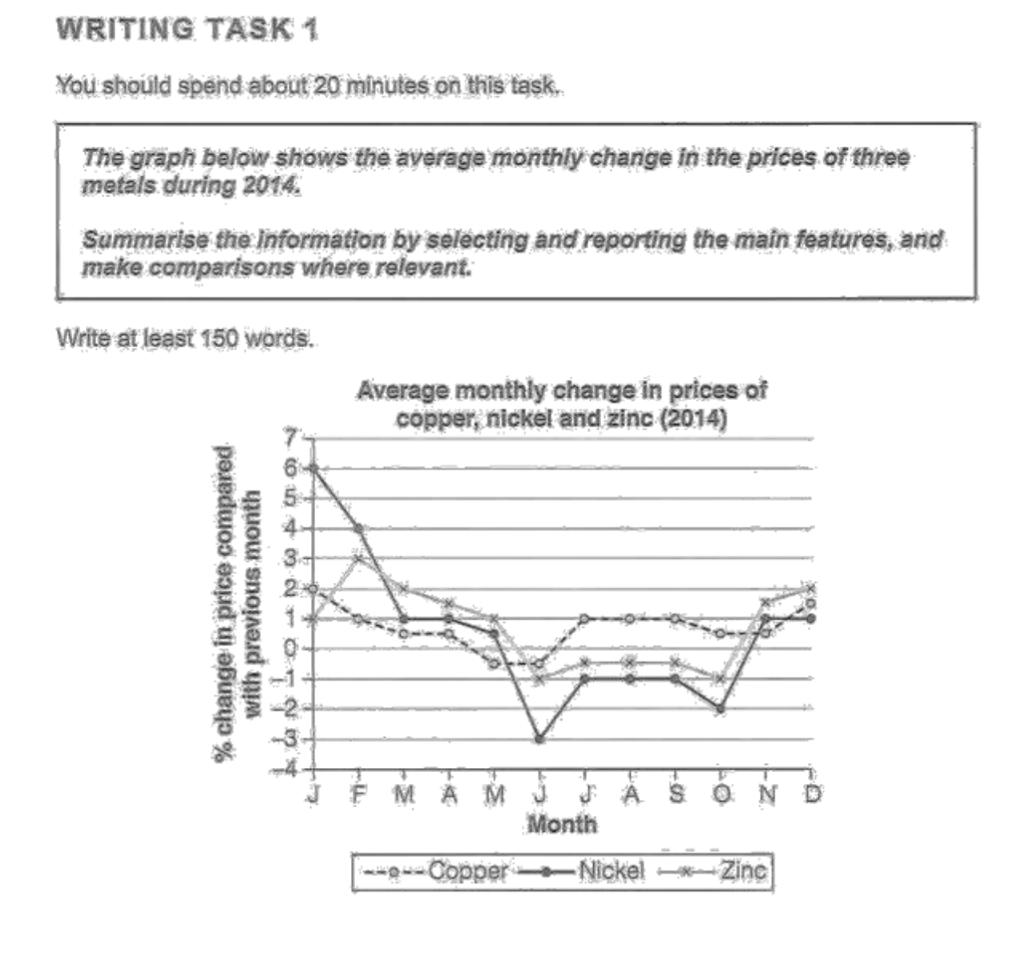



Ideas:

1. All metal prices rebound November onwards
2. Nickel has been the most dramatically affected metal that has dipped as much as its growth change since January and its trench touch happening at June.
3. Copper has remained stable throughout the year, mainly because of its extensive usage in electronics.

The line graph illustrates average month performances of metals such as Copper, Nickel and Zinc distributed in months within year 2014 and their change percentages displayed as compared to previous month.

Overall, most metal percentage values rebound to positive changes as compared to the previous months by the end of November whilst it can be observed the Nickel has been the most volatile metal in terms of percentage changes over the months. On the other hand, copper can be seen to remain stable over the year.

Metal rebounding to positive values by the end of the year as observed in the graph can be attributed to multiple factors. One of the factors might be for developing electronics near black Friday, as the sales of electronics bump up quickly during Christmas and Black Friday sales happening in the last 2 months. Secondly coins made by countries for currencies such as cents can also potentially contribute to the increase in value. Thus overall in 2014 year the trend of price changes to positive values can be clearly scene in the last 2 months of the year.

On the other hand, metals like Nickel have illustrated extreme fluctuations and mostly in the negative trend over the months with its highest being in January and lowest being in June. The reason might be because of less usage of Nickel in electronic production as Nickel electric conductivity might not be efficient as compared to Copper. Thus one of the reasons why Nickel has remained stable throughout the Year.

3rd party tool enhancement:

The line graph illustrates the average monthly performances of metals such as Copper, Nickel, and Zinc distributed in months within the year 2014 and their change percentages displayed as compared to the previous month.

Overall, most metal percentage values rebound to positive changes as compared to the previous months by the end of November whilst it can be observed that Nickel has been the most volatile metal in terms of percentage changes over the months. On the other hand, copper can be seen to remain stable over the year.

Metal rebounding to positive values by the end of the year as observed in the graph can be attributed to multiple factors. One of the factors might be for developing electronics near black Friday, as the sales of electronics bump up quickly during Christmas and Black Friday sales happening in the last 2 months. Secondly, coins made by countries for currencies such as cents can also potentially contribute to the increase in value. Thus overall in 2014 year, the trend of price changes to positive values can be seen in the last 2 months of the year.

On the other hand, metals like Nickel have illustrated extreme fluctuations and mostly in the negative trend over the months with its highest being in January and lowest being in June. The reason might be because of less usage of Nickel in electronic production as Nickel's electric conductivity might not be efficient as compared to Copper. Thus one of the reasons why Nickel has remained stable throughout the Year.

## Bar Graph:

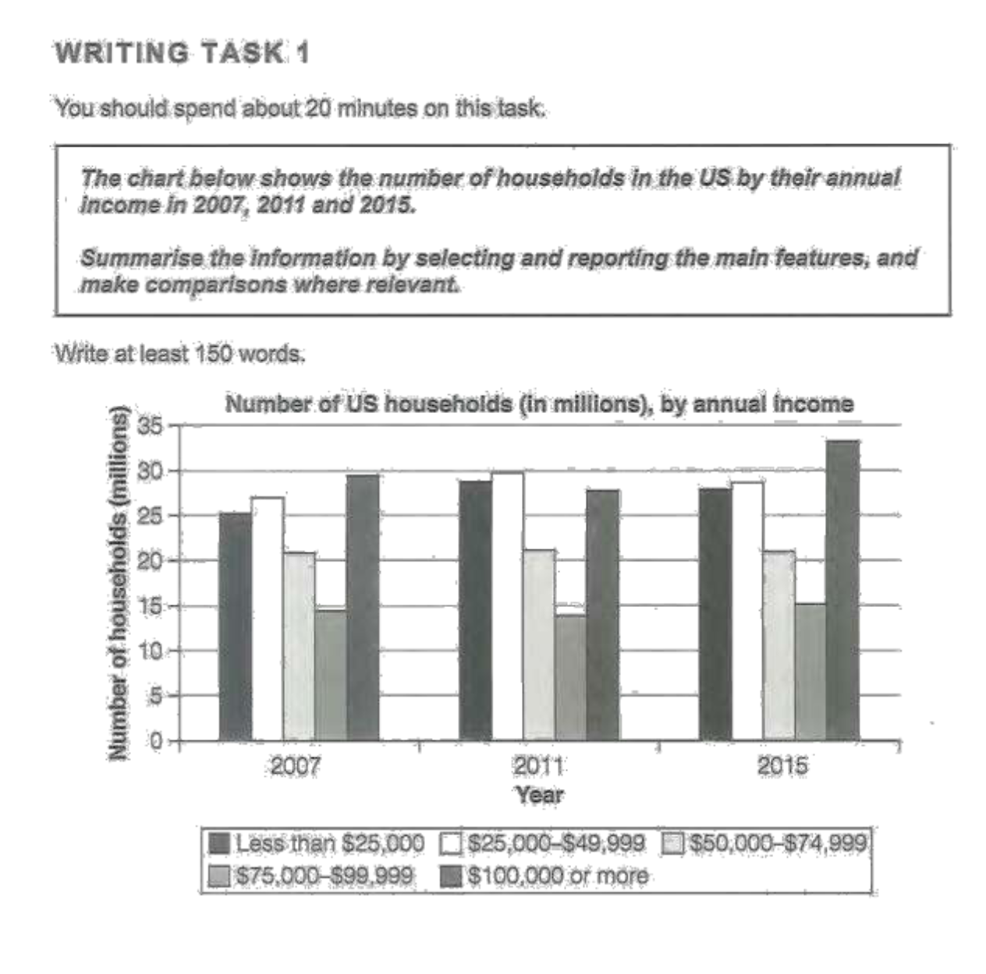



Ideas:

## Map:

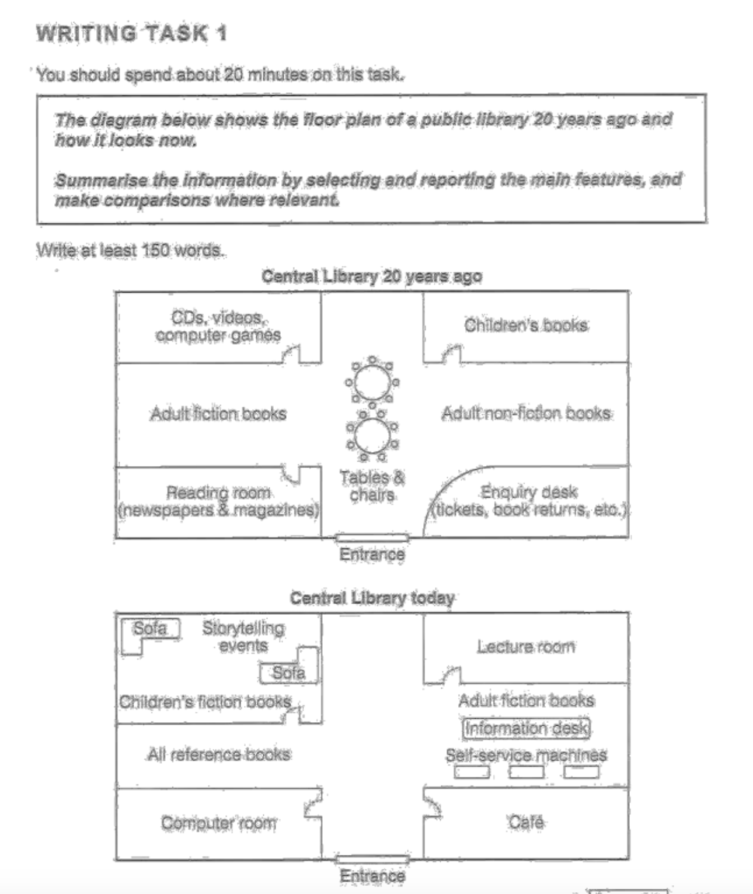



Ideas:

1. Library mostly automated today and legacy systems such as CDs, Enquiry desk have been updated to self service machines to handle book returns etc.
2. Library today has also been envisoned to become like a personal space for people adding sofas with story telling events.
3. Tables and chairs etc have been moved to Café, Lecture room etc where now people can share ideas whilst keep themselves fed and updated with lecturers provided latest information.